
Business Rules

NSLHD HITH SharePoint and Teams Channels

Version | Date | Authors | Reason | Sections
1.0 | 17/07/2024 | H Thomson  J Herrera | Initial draft for circulation & feedback | All
1.1 | 16/04/2025 | H Thomson | Review and second circulation for publication | All

Statement of Intent
Hospital in the Home have introduced Teams channels and SharePoint as the centralised location to store and share information relating to the service.
This document was developed to ensure a process of clear roles and responsibilities to facilitate efficient and effective information sharing and storage within Hospital in the Home.
- Definitions
Acronym | Definition
AHM | Allied Health Manager
CC | Clinical Coordinator
CNE | Clinical Nurse Educator
CNC | Clinical Nurse Consultant
EIC | Evening in Charge
HITH | Hospital in the Home
HITH NB | HITH Northern Beaches
HITH NS | HITH North Shore
NSLHD | Northern Sydney Local Health District
NUM | Nurse Unit Manager
NP | Nurse Practitioner
SharePoint | SharePoint refers to the online website interface of Microsoft teams
Teams | Microsoft application
Teams channel | Refers to individual channels within a team under the Microsoft application Teams

- Teams Structure
The structure of the HITH Teams Channels and SharePoint is outlined in detail below with each specific channel, its description, owners, and subscribers. Any changes to the structure of the channels must be made through the HITH Manager in consultation with the team.
All managers are to be given owner access to all team’s channels to facilitate governance and maintain subscription to each channel.
All channels sit under the parent team “NSLHD HITH”. When searching for a channel it will have the prefix – the channel name (NLSHD HITH - *channel name below*).
Channel Name | Description | Owner/s | Subscriber/s
Resources | The HITH resources channel will be the hub for information sharing within Hospital in the Home. It comprises of the HITH Resources SharePoint site, an internal intranet for updates, quick links, and easy to access information. And the document libraries that house all clinical and operational resources. See section 3a for further breakdown and processes regarding specifics with this resource site. | HITH Managers  CNCs  CNEs  Data Manager  *This site is locked and only owners can add or delete files* | All HITH staff  +/- VCS staff
Accreditation and Quality | Quality reports, audit reports, accreditation plans, and HITH plans, will all sit within this folder. As well as the evidence for all the above. The HITH CNCs will share the reports, and any other necessary teamwide information to the HITH resources site. | HITH Managers  CNCs | CNEs  CCs  NP
Administration | The administration channel will be utilised by the HITH admin team. It will contain the HITH database, reports, revenue information and HITH assets databases. | HITH Managers  Data Manager  Admin 5 | Admin 3  Admin 4  CSO
Allied Health Manager | Private channel for the HITH Allied Health Manager to store confidential staffing and service information. | Allied Health Manager  HITH Manager | AH Manager will temporarily assign access to acting staff
Clinical Coordinator | Private channel for HITH Clinical Coordinators to store confidential processes and/or information regarding staff | HITH Managers | All staff in, or acting in the Clinical Coordinator role
HITH Area Manager | Private channel for the HITH Area Manager to store confidential staffing and service information. | HITH Manager  Admin 5 | HITH Manager will temporarily assign access to acting staff
Intake | Private channel for the HITH Intake team to store confidential patient data and other resources not applicable to the wider team. | HITH Managers | Intake CNS2  EIC staff  CCs
Medical | Private channel for the HITH medical team to share resources not applicable to the wider team, including orientation resources. | HITH Managers  HITH Clinical Director | HITH/VCS SS  HITH JMO
Quality and Governance Meetings | The meetings channel will store all minutes, and resources applicable to the two Quality and Governance structured meetings within HITH – the clinical governance meeting and quality and clinical practice meeting. For discipline specific meetings please refer to the discipline specific folders. | HITH Managers | Senior HITH Team
NB NUM | Private channel for the HITH Northern Beaches NUM to store confidential staffing and service information. | NB NUM  HITH Manager | NB NUM or HITH Manager will temporarily assign access to acting staff
NS NUM | Private channel for the HITH North Shore NUM to store confidential staffing and service information. | NS NUM  HITH Manager | NS NUM or HITH Manager will temporarily assign access to acting staff
CCA | Private channel for the HITH CCAs to share resources not applicable to the wider team. | CCAs  HITH Managers | CSO  CCA
Occupational Therapy | Private channel for the HITH Occupational Therapists to share resources not applicable to the wider team. | AHM  HITH Manager | OT
Pharmacy | Private channel for the HITH Pharmacists to share and store resources not applicable to the wider team. Pharmacists can share links to documents applicable to other disciplines as “view only” | AHM  HITH Manager | Pharmacists
Physiotherapy | Private channel for the HITH Physiotherapists to share resources not applicable to the wider team. | AHM  HITH Manager | PTs
Senior Nursing | Senior nursing encompasses the clinical nurse educators, clinical nurse consultants, nurse practitioner and GP liaison. The channel contains all resources used across these disciplines that are not applicable to the wider team and allows for information sharing between these roles. | HITH Managers  CNE  CNC  NP  GP Liaison | N/A
Senior Management | The channel contains all resources used across the HITH Management team that are not applicable to the wider team and allows for information sharing between these roles. | HITH Managers  Admin5 | N/A
Social Work | Private channel for the HITH social workers to share resources not applicable to the wider team. | AHM | Social Workers

4. HITH Resources Channel
The HITH resources channel is split into two components:
- Document Libraries and folders - these house all HITH’s clinical and operational information. Responsibility for this section is outlined below in 4a.
- SharePoint Web Homepage – the SharePoint homepage has been developed as a HITH intranet that allows for fast and efficient dissemination of important information to all HITH staff and makes resources easy to access. The expectation of this page is to share links to the most current and relevant information for HITH clinicians. Responsibility for this section is outlined below in 4b.

4a. Document Libraries and Folders
Folders and information within these document libraries are to be maintained by the outlined person’s responsible below. Any change to the documents or libraries must be done in consultation with the person/s responsible.
Information is to be saved using the basic structure below:
- No polices or procedures to be saved in SharePoint – PROMPT only
- Where possible link to external SharePoint sites to allow for the most up to date information
- If saving clinical information – you are responsible for the upkeep of information saved
- Any clinical information should be reviewed at a minimum every 2 years
- Author and date of review/creation to be save in the footer

Any major changes to the structures of these libraries must be requested through the HITH Manager.
Library | Description | Person Responsible | Contact Details
Clinical Resources | Document library where all clinical resources relating to HITH are stored. | Horst Thiele  Michelle Lane  Heather Thomson
Operational Resources | Document library where all operational resources relating to HITH are stored. | Amy Herdman  Therese Coleman  Neelam Sood
Quality and Accreditation | Document libraries that include the HITH performance board, HITH Audits and HITH Accreditation | Michelle Lane  Heather Thomson  Shelley Somi
Education | Document Libraries that include the HITH Education Board, Presentation and In-services and Orientation | Kate Lock  Samantha Chan
Meetings | Operational Team Meetings  Allied Health and Nursing Huddles | Marzia  Neelam
Work, Health and Safety |  | Rachelle Foxton

4b. SharePoint Homepage
Please note: The NSLHD has an intranet that has a HITH page that allows external NSW Health staff to gain an understanding of HITH, its processes and referral criteria. This document talks about the HITH intranet which is the HITH Teams Channel “resources” this will be utilised as a HITH intranet that facilitates information sharing in one place for all HITH staff.
The Hospital in the Home SharePoint site has been developed as a HITH intranet that allows for fast and efficient dissemination of important information to all HITH staff and makes resources easy to access.
The HITH Notice Board is the front page of the HITH intranet. It contains four main sections which are described below along with responsibility and access request processes:
- Latest updates: The first section of the HITH noticeboard is a space to put all latest updates relating to the service including conferences, updated or new projects and/or seasonal important information, alerts

Requests to add information to “latest updates” must be made through the HITH Manager and will be actioned via Admin 5

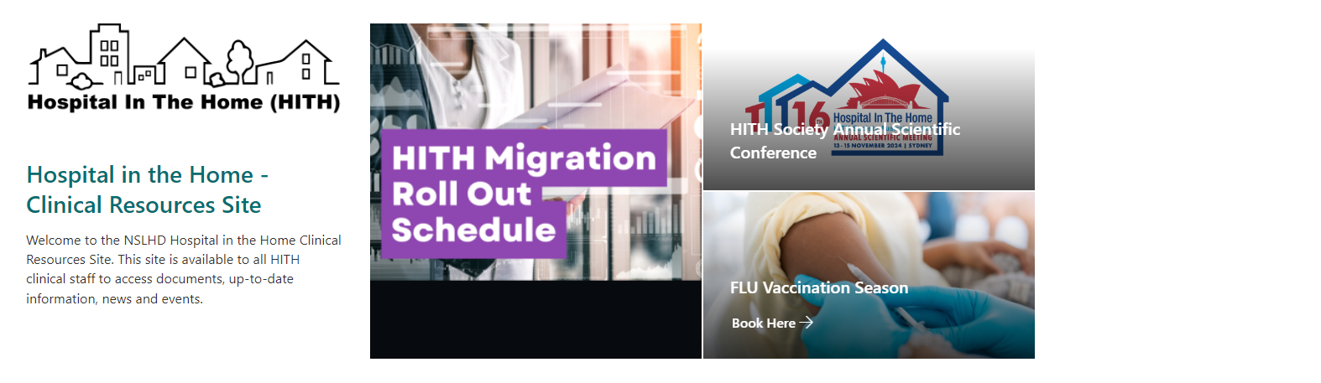
- Latest Care Modalities, Polices and Procedures: This section contains links to the latest modalities, policies and procedures that have been updated in Hospital in the Home or are being highlighted due to practice changes and/or education needs.

Requests to add information to “latest care modalities, policies and procedures” must be made through the HITH CNC

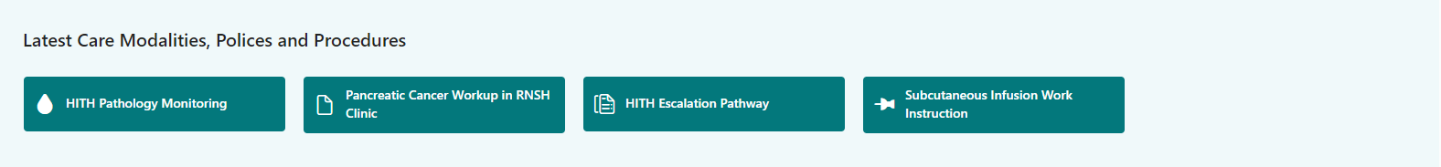

- Shortcuts to staff resources: This section contains shortcuts to useful staff resources including roster requests, phone lists etc. Each link is maintained from its original source.

Requests to add a shortcut must be made through the HITH Manager and will be actioned via Admin 5

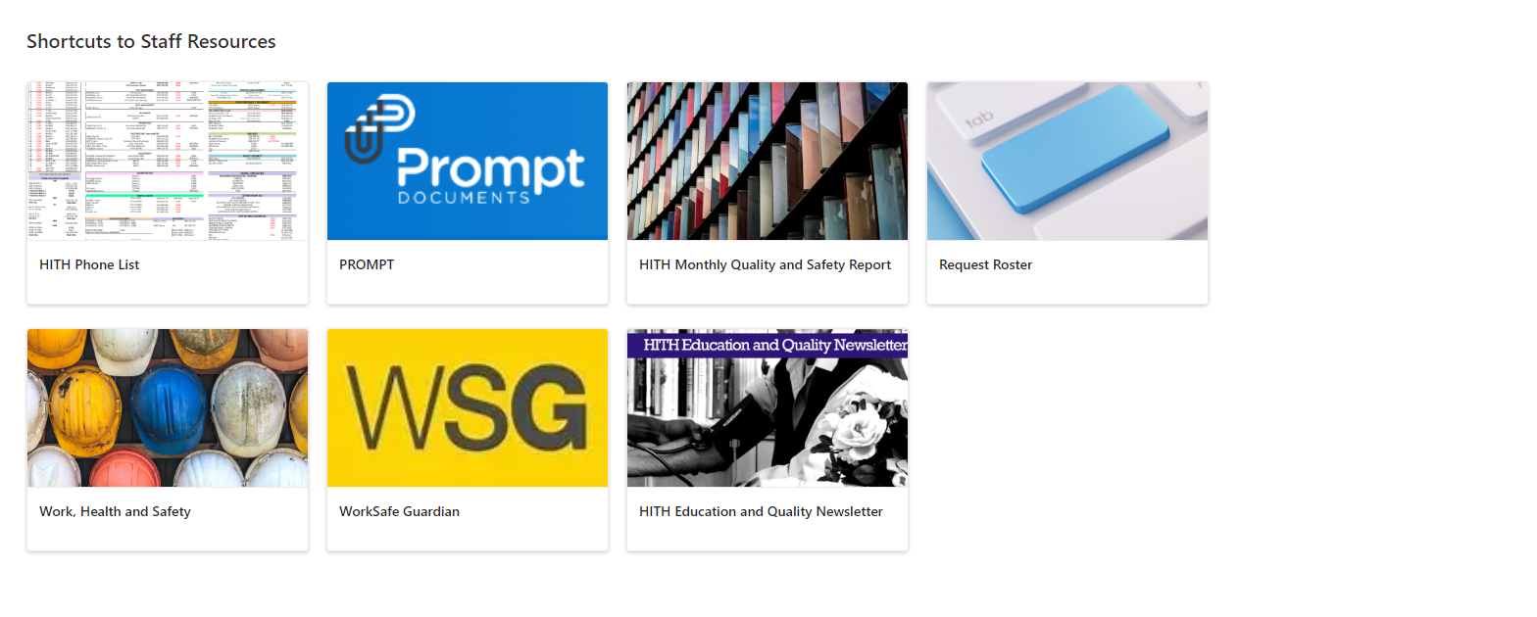
- Upcoming events in Hospital in the Home: This section works as a calendar for any in-services or events within Hospital in the Home.

Any owner can add events to this section. HITH CNEs will signpost education sessions.

